MGT 581 – Entrepreneurship
Dr. Mario Hayek
Market Analysis/Opportunity Recognition
5/17/2017

Market Analysis
Creating and operating a successful taco shop can certainly be a challenging feat. Not only does it require hard work, but it brings along increased competition. In this overall Market Analysis, we will determine the broad environmental analysis, an industry analysis, a target market, a competition analysis and a SWOT analysis.
Establishing and operating a taco shop may seem simple, however, in conducting an environmental analysis, it is easy to see that the word simple is not the case. We are currently experiencing political turmoil in the United States of America. Our new President, Donald Trump, has tightened his grip around immigration policies. Immigrants are now finding it harder to live and travel freely here in the status due to these stricter immigration laws. Tacos are an authentic Mexican food which have gained massive popularity here in the U.S. Most authentic Mexican taco shops are typically owned and operated by hard working Mexican immigrants. They provide the genuineness and authenticity of this delicious food genre. You cannot go to Taco Bell or Taco Bueno and expect to experience the greatness of Mexican tacos. Your best bet to experience true genuine tacos would be to go to a “hole in the wall” type taco shop in the local area. With stricter immigration policies, Mexican immigrant business owners find it riskier to continue operating their businesses. Many business owners will want to liquidate and cash in on their successful business ventures to avoid possible future legal issues. Social media and other forms of media platform includes stories of many individuals whom have been deeply affected by this. A key thing to point out here is that this significantly reduces competition, especially in the Mexican food/restaurant arena. Demand for Mexican food in general will always be high, especially in the state of Texas. Although, stricter immigration laws and policies have become of this nation, we still continue to experience a vast and increasing immigrant population. According to an article on prweb.com, “In response to an expanding immigrant population, restaurants are adapting to increasing demand for ethnic foods, particularly for Mexican cuisine. According to IBISWorld industry analyst Agata Kaczanowska, “Mexican-style food has been introduced into mainstream American culture through rapid growth in brands like Chipotle Mexican Grill.” This article also notes that Chipotle’s revenue increased “at an average annual rate of about 20.5% over the past five years, including a 21.5% leap in 2012 alone.” This speaks for itself, and to be honest, Chipotle is not considered to be an authentic Mexican food provider. Imagine if an educated business owner and his/her team with great overall business acumen (in sales, marketing, distribution, etc.) was able to run a successful taco shop with authentic Mexican tacos in a similar fashion as that of Chipotle. The profits would be exponential. Operating a taco shop also involves many tax regulations. As a taco shop business owner, we can procure non-reusable items such as forks, spoons, napkins, straws etc., and not have to pay any taxes. Of course, a resale certificate will need to be obtained by the business owner. This certainly aids in realizing overall profit in the company. In running a taco shop, there will be a need to procure the necessary equipment and machinery to be able to create and process delicious authentic tacos. Again, the procurement of this behind the scene equipment is not taxable. On the other hand, equipment that helps in operating the taco shop such as “tables, chairs, trays, glasses, dishes, serving utensils, reusable menus and placemats, silverware, tablecloths, and cloth napkins” are taxable. The electricity, gas, water, and other services provided to the taco shop are also taxable items. All of this information, and much more, is provided at comptroller.texas.gov. The taco shop business we intend on pursuing will be located on Fry street right beside the University of North Texas. The demographics of the population around this area is that of low and average income level students in the 18 to 40 year old range. Most individuals are single and typically have part time jobs. Many individuals in this area are younger students with no children, however professors and older individuals with families also make up the population/market of this area. Collegefactual.com provides valuable information with regards to both the sexual and ethnic diversities at the University of North Texas. Appendix A demonstrates these details. The University of North Texas has been growing and the numbers of students enrolled has been increasing steadily. Appendix B illustrates the steady increase from 2011 to 2016. The link provided will also provide additional data from previous years. The assumption is that these UNT college students will be the major customers for the procurement of tacos from this business.
Performing an industry analysis is obligatory when pursuing a self-made business. Operating a taco shop business is quite common however much thought is not given to the location of where these taco shops operate. As previously stated, there is much competition in the Mexican food industry. The industry size is ginormous if you stay within the Mexican food genre, however it is rather small if you compare it to quick service restaurants, or QSRs, all over the country. Quick service restaurants typically do not have a waiter, and the food is normally inexpensive. There are no condiments such as napkins and silverware available at every table, however these condiments are located a central location in the QSR. The taco shop business we will operate falls under the QSR category. There is a “Fast Food Industry Analysis” that was conducted via franchisehelp.com which provides very fascinating information. “The United States fast food market continues to be dominated by hamburger fast food restaurants, accounting for over 30% of industry sales. However that market share is sliding, and Mexican food in particular has been gaining.” Mexican food is quite popular, and sales for this food genre have certainly been increasing. The information below was obtained from franchisehelp.com:
Segment | Market Share
Hamburger-focused restaurants | 30%+
Pizza parlors | 15%
Sandwich shops | 12%
Chicken restaurants | 8%
Mexican restaurants | 7%

Currently, Mexican restaurants have the smallest market share, so there is certainly room for expansion and improvement. It is safe to say that the demand for tacos, and the Mexican food industry, is growing, and will continue to grow. Although the attractiveness of this industry is respectable, this will not guarantee positive results. There are critical factors that one must take into consideration when operating a business. Customer service, speed of service, quality of food, cleanliness, and overall culture all play a significant role in the profitability of operating a business.
The target market is mainly composed of students and professors. Local citizens/residents of the area will also contribute to the business market. As noted beforehand, Mexican food is increasing in popularity and market share. Students particularly live a “on the go” type schedule during the college years. There is downtime in between classes and students typically choose to eat and do homework/studying while waiting for the next class to start. A taco shop with authentic and affordable food, speedy service, and Wi-Fi service provides a perfect quick meal opportunity for the average student. The location of a taco shop near multiple bars provides a perfect business opportunity for the increase in sales. Alcohol in the human system tends to increase hunger. As stated by Osterath, “In mice studies, they identified a type of brain cell that fires in the presence of alcohol. These same brain cells are active when the body is starving, telling us it is high time to consume a lot of high-caloric food.” College students tend to consume alcohol at a higher than average rate than most of the population. Associating alcohol with authentic Mexican tacos provides for a good business scenario. Of course, people cannot eat tacos every day and forever. A change in food genre throughout the week is very understandable. The target market/consumers for authentic Mexican tacos will not be exclusive however the sheer high demand and popularity for high quality tacos will prove to be significantly favorable. Our target market will not give up the use of Jack in the Box, for example. In having consumers switch from another Mexican taco shop provider, the list below can considerably provide a need for change.
1.) Close proximity to the University
2.) Ease of access
3.) High quality food at an affordable price
4.) Speedy service
5.) Great customer service
6.) Free Wi-Fi
7.) Close proximity to local bars and entertainment
8.) Active involvement in the community
This list will prove to be essential in successfully operating a taco shop and convincing consumers on making a switch.
Competitive Analysis
The competitive analysis is a critical component to business planning. It allows one the ability to access and identify competitors while evaluating their strategies to determine their strengths and weaknesses.
Current Competitors Our nearest competitor is Chipotle Mexican Grill. Our next closest competitors are two small family-owned restaurants. These two restaurants are: Fuzzy’s Taco Shop and Digg’s Taco Shop. The in-town taco shops will be competitors. Fuzzy’s and Digg’s Taco Shops are the two that have been around for over a decade. Digg’s Taco Shop is the newest to the market; opened less than 6 months ago. All three competitors have an established reputation, chipotle being the most well known nationally. On Google, Digg’s Taco Shop has the highest rating; Fuzzy’s is rated the second highest; and Chipotle has the third highest rating.
[Competitor logos]
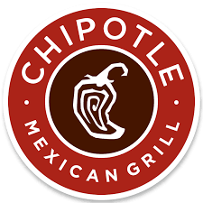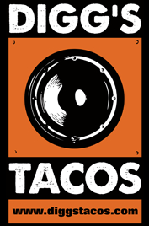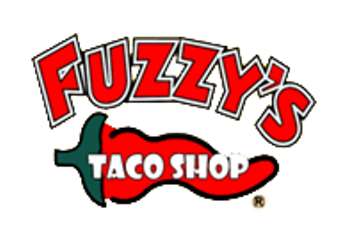
Potential Competitors Besides Chipotle Mexican Grill being within 5 miles of the University of North Texas, and the other two restaurant nearby but not as well known, there is potential for new restaurants to open in the area as there is ample space in various commercial properties in the university district. However, local restaurants do compete with selling select items on their menus that is considered “Mexican dishes”, however, the restaurant is not a taco shop. Later, after being open for over 6 months and potential competitors see the success of the taco shop, the lingering of competition may fill the local vacant nearby building spaces. We will compete by bringing a fresh new restaurant to the area for students, staff and nearby locals and visitors to choose from. We will offer competitive prices on our menu that is of quality and value. Our menu will not be convoluted; rather, it will be limited and easily read.
Competitor strengths
- Also offering quality food and affordable prices, as we provide customers the opportunity to experience our food and compare that to food on campus or from nearly restaurants
- Offering monthly specials or incentives (for example: buy 5 tacos, get 2 free) similar to our specials which is intended to keep customers happy and engaged.
- Offering drive-thru option for extended options of convenience as we will have a drive-thru option available
- Opening the avenue for online ordering. We will have a newly designed app for easy access to order and pickup
- Offering a prime location that is accessible to the university campus as well as outside traffic
Competitor weaknesses
- Not understanding the market demand in conjunction with the college lifestyle
- Lack of effective marketing re: affordable pricing on the menu to cater to college students
- Lack of high quality products
- Lack of reputation within the university campus
- Not offering technology, such as free Wi-Fi to customers

SWOT Analysis
A SWOT analysis consists of the strengths, weaknesses, opportunities and threats of an organization. Within our taco shop we foresee our SWOT as such:
Strengths  - High quality product  - Great location – across the street from college campus with high visibility  - Affordable prices for college students  - Free Wifi to customers | Weaknesses  - Owners lack business experience  - Target market is not stable as college students, staff and nearby neighbors are unfamiliar with brand
Opportunities  - Market potential: college students are on a budget and Mexican food is affordable  - Popularity; Mexican food has gained in popularity over the years | Threats  - Three restaurants nearby within a 5 mile radius  - Chipotle is 5 miles away and has a known reputation  - Due to economic recession, people have reduced dining out  - Some health reports indicate Mexican food can be “unhealthy”

Marketing Plan
Mission Statement
Taco shop’s mission is to offer Mexican Tacos as well as other dishes including rice, beans, quesadillas and tortas at student friendly prices. The current offering of fast foods around the University of North Texas means that there is a great opportunity to introduce competing styles of cuisines to cater for the diverse needs of the students. By offering uniquely flavored Mexican style foods at student friendly prices, we hope to achieve rapid growth and tap into the huge market demand and student population around the University of Texas. We will use aggressive marketing through brochures, promotions and word of mouth advertisement to reach to as many students as possible and inform them about our product offering. This will build a large clientele around our product and enable the business to achieve the mission objectives.
Vision
The vision for our Taco shop is to become the largest provider of Mexican style cuisines and other dishes not only around the University of North Texas but also in other major markets around and outside the United States.
Objectives
Our objective for establishing the a Taco shop close to the University of North Texas is to offer the Mexican tacos and other dishes and attain a market share of 20 percent within one year of operation. We intend to achieve this objective by offering high quality dishes and friendly customer service to the students. Also, we aim to reduce our operational costs by at least 10 percent within one year which will be achieved through operations on economies of scale. This will enable us to price our dishes more competitively given that students operate on tight budgets and would love to dine in low cost restaurants. Our other objective is to expand our taco shop outside the University location to other areas such as the Las Vegas area which is known to have a huge population of mixed races that would love our dishes. Our objectives are specific, measurable, attainable, realistic and time-bound (SMART). We intend to achieve this objective within 2 years of operation which will enable us to grow out market share by at least 10 percent.
Product
The product we intend to offer is simply the authentic Mexican Tacos as well as other delicious dishes such as rice, beans, quesadillas and tortas. Ideally, maintaining a small menu will make it easy for us to offer specialized services and quality meals that will enhance repeat purchase and build and loyal clientele. We believe that there is a huge market for our product given the high population around the University of North Texas as well as lack of a direct competitor for similar products. We will deliver our product in a customer friendly and cost effective way to maintain a loyal client base and overcome the huge competition likely to be faced. Our product will target mostly the students who will be the majority, the professors, university employees and locals in the area. Students will have a place to hang out between and after classes in out shop since we have realized that there a lot of downtime that they usually possess during such times.

Appendix A
Ethnic & Sexual Diversity at University of North Texas
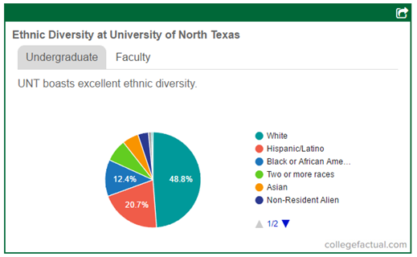
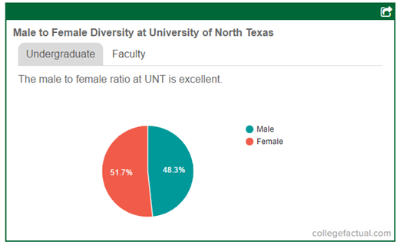

Appendix B
Enrollment by Classification & Level
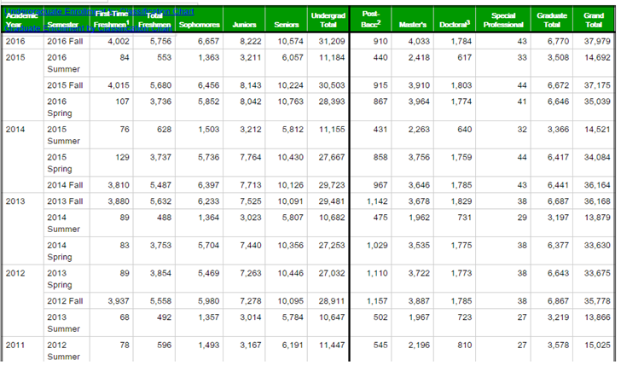

References

Enrollment by Classification & Level. (2017, January 11). Retrieved from
https://institutionalresearch.unt.edu/facts-figures/fact-book/enrollment-2013-2014
Fast Food Industry Analysis 2017 - Cost & Trends. (2017) Retrieved from
https://www.franchisehelp.com/industry-reports/fast-food-industry-report/
How Diverse is University of North Texas? (2017). Retrieved from
https://www.collegefactual.com/colleges/university-of-north-texas/student-life/diversity/
Mexican Restaurants in the US Industry Market Research Report Now Available from
IBISWorld. (2012, November 20). Retrieved from
http://www.prweb.com/releases/2012/11/prweb10153448.htm
Restaurants and the Texas Sales Tax. (2014, March). Retrieved from
https://comptroller.texas.gov/taxes/publications/94-117.php
Osterath, B. (2017, December 1). Why drinking alcohol makes us hungry. Retrieved from
http://www.dw.com/en/why-drinking-alcohol-makes-us-hungry/a-37111288

